**Supply Chain Logistic**

SELECT *

FROM [Supply].[dbo].[Supply Chain Returns 250224 (1)]

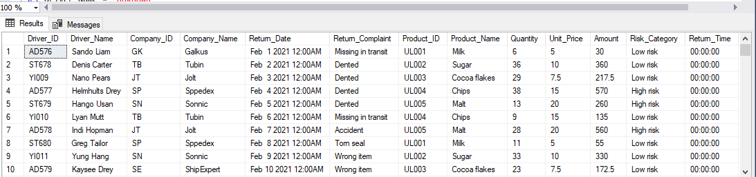

--Removing duplicate

WITH CTE AS (

SELECT *,

ROW_NUMBER() OVER (PARTITION BY Driver_ID, Return_Date, Product_ID ORDER BY (SELECT NULL)) AS RowNum

FROM [Supply].[dbo].[Supply Chain Returns 250224 (1)]

)

DELETE FROM CTE

WHERE RowNum > 1;

--Handing Missing Values

UPDATE [Supply].[dbo].[Supply Chain Returns 250224 (1)]

SET Driver_Name = 'Unknown'

WHERE Driver_Name IS NULL OR Driver_Name = '';

UPDATE [Supply].[dbo].[Supply Chain Returns 250224 (1)]

SET Company_Name = 'Unknown'

WHERE Company_Name IS NULL OR Company_Name = '';

UPDATE [Supply].[dbo].[Supply Chain Returns 250224 (1)]

SET Return_Complaint = 'Unknown'

WHERE Return_Complaint IS NULL OR Return_Complaint = '';

--Convert Return_Date to Date Format

UPDATE [Supply].[dbo].[Supply Chain Returns 250224 (1)]

SET Return_Date = DATEADD(DAY, CAST(Return_Date AS INT), '1899-12-30');

select [Return_Date]

FROM [Supply].[dbo].[Supply Chain Returns 250224 (1)]

UPDATE [Supply].[dbo].[Supply Chain Returns 250224 (1)]

SET Return_Date = DATEADD(DAY, TRY_CAST(Return_Date AS INT), '1899-12-30')

WHERE TRY_CAST(Return_Date AS INT) IS NOT NULL;

--Check for Missing Values in Key Columns

SELECT *

FROM [Supply].[dbo].[Supply Chain Returns 250224 (1)]

WHERE Driver_ID IS NULL OR Driver_ID = ''

OR Company_ID IS NULL OR Company_ID = ''

OR Product_ID IS NULL OR Product_ID = '';

--Final Check for Clean Data

-- Check for duplicates

SELECT Driver_ID, Return_Date, Product_ID, COUNT(*) AS Count

FROM [Supply].[dbo].[Supply Chain Returns 250224 (1)]

GROUP BY Driver_ID, Return_Date, Product_ID

HAVING COUNT(*) > 1;

-- Check for missing values

SELECT *

FROM [Supply].[dbo].[Supply Chain Returns 250224 (1)]

WHERE Driver_Name IS NULL OR Company_Name IS NULL OR Product_Name IS NULL;

-- Ensure Return_Date is in DATETIME format

SELECT CAST(Return_Date AS DATETIME) AS Converted_Return_Date

FROM [Supply].[dbo].[Supply Chain Returns 250224 (1)];

-- Extract time part

SELECT CONVERT(VARCHAR(8), CAST(Return_Date AS DATETIME), 108) AS Return_Time

FROM [Supply].[dbo].[Supply Chain Returns 250224 (1)];

-- Add a new column for time

ALTER TABLE [Supply].[dbo].[Supply Chain Returns 250224 (1)]

ADD Return_Time VARCHAR(8);

-- Update the new column with the extracted time

UPDATE [Supply].[dbo].[Supply Chain Returns 250224 (1)]

SET Return_Time = CONVERT (VARCHAR (8), CAST (Return_Date AS DATETIME), 108);

--create a month column

ALTER TABLE [Supply].[dbo].[Supply Chain Returns 250224 (1)]

ADD Return_Month AS MONTH(CONVERT(DATE, Return_Date));

ALTER TABLE [Supply].[dbo].[Supply Chain Returns 250224 (1)]

ADD Return_MonthName AS DATENAME(MONTH, CONVERT(DATE, Return_Date));

--create a days column

ALTER TABLE [Supply].[dbo].[Supply Chain Returns 250224 (1)]

ADD Return_Day AS DAY(CONVERT(DATE, Return_Date));

ALTER TABLE [Supply].[dbo].[Supply Chain Returns 250224 (1)]

ADD Return_Weekday AS DATENAME(WEEKDAY, CONVERT(DATE, Return_Date));

--create a Year column

ALTER TABLE [Supply].[dbo].[Supply Chain Returns 250224 (1)]

ADD Return_Year AS YEAR(Return_Date);

SELECT *

FROM [Supply].[dbo].[Supply Chain Returns 250224 (1)]

-- Total Amount

SELECT SUM(CAST (Amount AS Float)) AS total_Amount

FROM [Supply].[dbo].[Supply Chain Returns 250224 (1)];

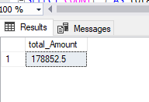

--Get a breakdown of product types

SELECT Product_Name, COUNT(*) AS Product_count

FROM [Supply].[dbo].[Supply Chain Returns 250224 (1)]

GROUP BY Product_Name;

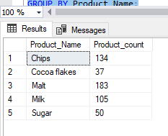

--Count the total number of products in the dataset

SELECT COUNT(*) AS total_Product

FROM [Supply].[dbo].[Supply Chain Returns 250224 (1)];

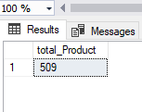

--Total Amount by Risk Category

SELECT Risk_Category, SUM(CAST (Amount AS FLOAT)) AS Total_Amount

FROM [Supply].[dbo].[Supply Chain Returns 250224 (1)]

GROUP BY Risk_Category;

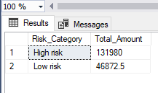

--Average Quantity and Amount by Company

SELECT Company_Name, AVG(CAST (Quantity AS FLOAT)) AS Avg_Quantity, AVG(CAST (Amount AS FLOAT)) AS Avg_Amount

FROM [Supply].[dbo].[Supply Chain Returns 250224 (1)]

GROUP BY Company_Name;

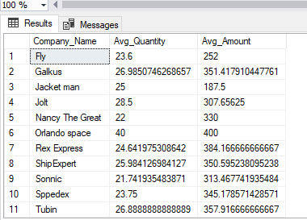

--Top 3 Products by Total Amount

SELECT TOP 3 Product_Name, SUM(CAST (Amount AS FLOAT)) AS Total_Amount

FROM [Supply].[dbo].[Supply Chain Returns 250224 (1)]

GROUP BY Product_Name

ORDER BY Total_Amount DESC;

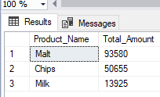

--Count of Complaints by Risk Category

SELECT Risk_Category, COUNT(*) AS Complaint_Count

FROM [Supply].[dbo].[Supply Chain Returns 250224 (1)]

GROUP BY Risk_Category;

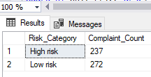

--Product with the Highest Unit Price

SELECT TOP 1 Product_Name, Unit_Price

FROM [Supply].[dbo].[Supply Chain Returns 250224 (1)]

ORDER BY Unit_Price DESC;

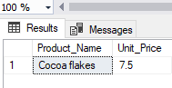

--Total Amount and Quantity by Driver

SELECT Driver_Name, SUM(CAST (Amount AS FLOAT)) AS Total_Amount, SUM(CAST (Quantity AS FLOAT)) AS Total_Quantity

FROM [Supply].[dbo].[Supply Chain Returns 250224 (1)]

GROUP BY Driver_Name;

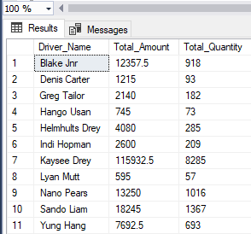

--Total Amount and Average Unit Price by Risk Category

SELECT Risk_Category, SUM(CAST (Amount AS FLOAT)) AS Total_Amount, AVG(CAST (Unit_Price AS FLOAT)) AS Avg_Unit_Price

FROM [Supply].[dbo].[Supply Chain Returns 250224 (1)]

GROUP BY Risk_Category;

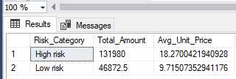

--Driver with the Highest Total Amount

SELECT TOP 1 Driver_Name, SUM(CAST (Amount AS FLOAT)) AS Total_Amount

FROM [Supply].[dbo].[Supply Chain Returns 250224 (1)]

GROUP BY Driver_Name

ORDER BY Total_Amount DESC;

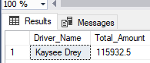

--Product with the Lowest Quantity

SELECT TOP 1 Product_Name, MIN(Quantity) AS Lowest_Quantity

FROM [Supply].[dbo].[Supply Chain Returns 250224 (1)]

GROUP BY Product_Name

ORDER BY Lowest_Quantity ASC;

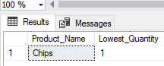

--Company with the Most Complaints

SELECT Company_Name, COUNT(*) AS Complaint_Count

FROM [Supply].[dbo].[Supply Chain Returns 250224 (1)]

GROUP BY Company_Name

ORDER BY Complaint_Count DESC;

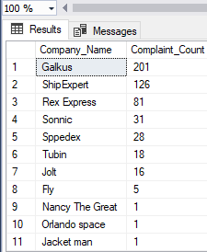

--Total Amount and Quantity by Product and Risk Category

SELECT Product_Name, Risk_Category, SUM(CAST (Amount AS FLOAT)) AS Total_Amount, SUM(CAST (Quantity AS FLOAT)) AS Total_Quantity

FROM [Supply].[dbo].[Supply Chain Returns 250224 (1)]

GROUP BY Product_Name, Risk_Category

ORDER BY Product_Name, Risk_Category;

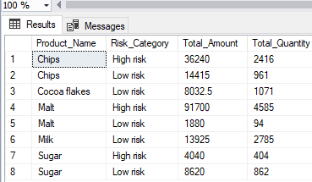

--Top 5 Products by Quantity Sold

SELECT TOP 5 Product_Name, SUM(CAST (Quantity AS FLOAT)) AS Total_Quantity

FROM [Supply].[dbo].[Supply Chain Returns 250224 (1)]

GROUP BY Product_Name

ORDER BY Total_Quantity DESC;

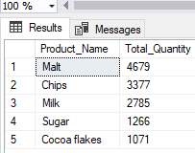

--Comparison of Average Unit Price by Product Name and Risk Category

SELECT Product_Name, Risk_Category, AVG(CAST (Unit_Price AS FLOAT)) AS Avg_Unit_Price

FROM [Supply].[dbo].[Supply Chain Returns 250224 (1)]

GROUP BY Product_Name, Risk_Category

ORDER BY Product_Name, Risk_Category;

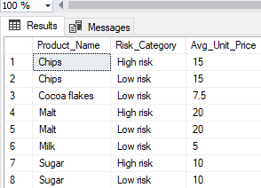

--Count of Complaints by Product and Risk Category

SELECT Product_Name, Risk_Category, COUNT(*) AS Complaint_Count

FROM [Supply].[dbo].[Supply Chain Returns 250224 (1)]

GROUP BY Product_Name, Risk_Category

ORDER BY Product_Name, Risk_Category;

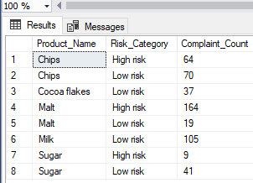

--Total Amount by Driver and Product

SELECT Driver_Name, Product_Name, SUM(CAST (Amount AS FLOAT)) AS Total_Amount

FROM [Supply].[dbo].[Supply Chain Returns 250224 (1)]

GROUP BY Driver_Name, Product_Name

ORDER BY Driver_Name, Total_Amount DESC;

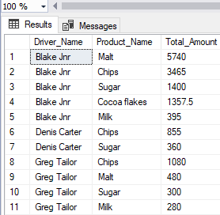

--Total Amount by Month

SELECT Return_MonthName, SUM(CAST (Amount AS FLOAT)) AS Total_Amount

FROM [Supply].[dbo].[Supply Chain Returns 250224 (1)]

GROUP BY Return_MonthName

ORDER BY Return_MonthName;

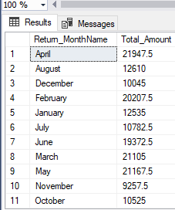

SELECT *

FROM [Supply].[dbo].[Supply Chain Returns 250224 (1)]

--Total Complaints by Day

SELECT Return_Weekday, COUNT(*) AS Total_Complaints

FROM [Supply].[dbo].[Supply Chain Returns 250224 (1)]

GROUP BY Return_Weekday

ORDER BY Return_Weekday;

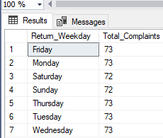

--Total Amount by Year and Month

SELECT Return_Year, Return_MonthName, SUM(CAST (Amount AS FLOAT)) AS Total_Amount

FROM [Supply].[dbo].[Supply Chain Returns 250224 (1)]

GROUP BY Return_Year, Return_MonthName

ORDER BY Return_Year, Return_MonthName;

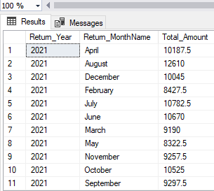

--Count of Complaints by Year and Risk Category

SELECT Return_Year, Risk_Category, COUNT(*) AS Complaint_Count

FROM [Supply].[dbo].[Supply Chain Returns 250224 (1)]

GROUP BY Return_Year, Risk_Category

ORDER BY Return_Year, Risk_Category;

